How to configure and use SRU | 
Yoel Kortick. Senior Librarian, Ex Libris

ONE
The only required configuration for the institution to use SRU is to define an SRU integration profile. For information regarding the profile see:
See:
- https://knowledge.exlibrisgroup.com/Alma/Product_Documentation/010Alma_Online_Help_(English)/090Integrations_with_External_Systems/030Resource_Management/190SRU_SRW_Search
- https://developers.exlibrisgroup.com/alma/integrations/SRU

Here is an SRU profile:

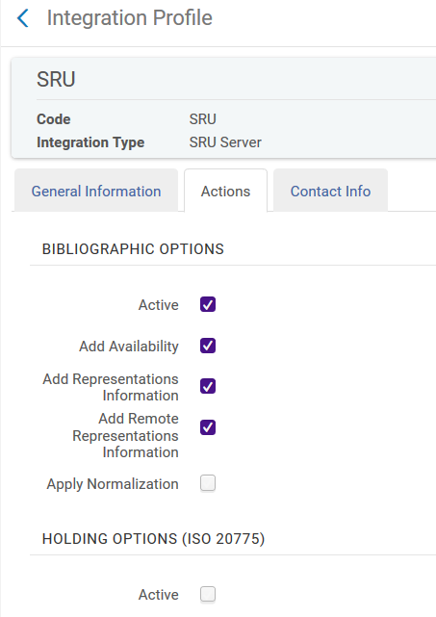

TWO

Once the integration profile is set up it can be used. No other configuration is required.
The base URL for SRU requests is:
- https://<Alma domain>/view/sru/<institution code>

For example if the Alma URL is:
- http://eu00.alma.exlibrisgroup.com/institution/EXLDEV1_INST

Then the base URL for SRU requests is:
- http://eu00.alma.exlibrisgroup.com/view/sru/EXLDEV1_INST
This is the syntax to search all fields for text "history":
- https://Alma domain/view/sru/institution_code?version=1.2&operation=searchRetrieve&recordSchema=marcxml&query=alma.all_for_ui=history

In our institution the syntax to search all fields for text "history" is:
- http://eu00.alma.exlibrisgroup.com/view/sru/EXLDEV1_INST?version=1.2&operation=searchRetrieve&recordSchema=marcxml&query=alma.all_for_ui=%22history%22

Searching for ISBN 9780385349949 would be as follows:
- http://eu00.alma.exlibrisgroup.com/view/sru/EXLDEV1_INST?version=1.2&operation=searchRetrieve&recordSchema=marcxml&query=alma.isbn=9780385349949

The full list of possible search indexes can be retrieved as follows:
- http://eu00.alma.exlibrisgroup.com/view/sru/EXLDEV1_INST?version=1.2&operation=explain

The possible indexes appear in the name set:

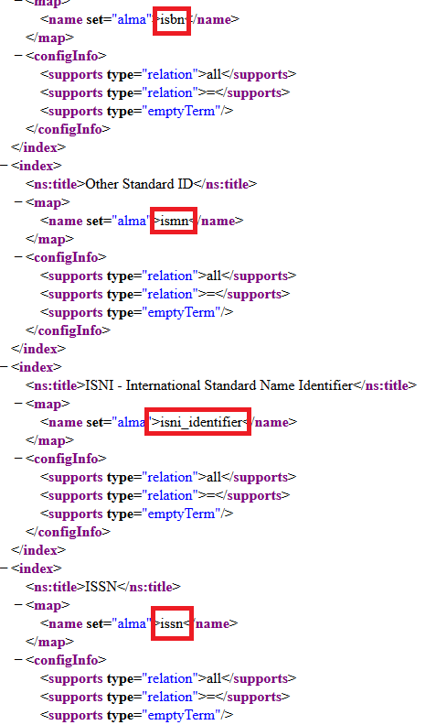

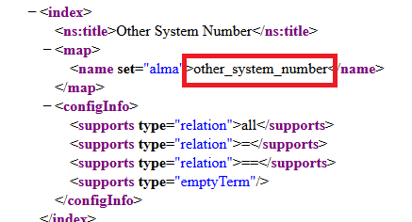

THREE

For example we see above that there is an option to search by other_system_number

So …

Since this is the syntax to search by ISBN 9780385349949:
- http://eu00.alma.exlibrisgroup.com/view/sru/EXLDEV1_INST?version=1.2&operation=searchRetrieve&recordSchema=marcxml&query=alma.isbn=9780385349949

Then this is the syntax to search by other system number (OCoLC)813526963
- http://eu00.alma.exlibrisgroup.com/view/sru/EXLDEV1_INST?version=1.2&operation=searchRetrieve&recordSchema=marcxml&query=alma.other_system_number=(OCoLC)813526963

Here is the beginning of the record

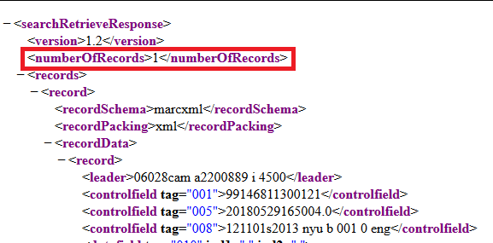

Here is the other_system_number

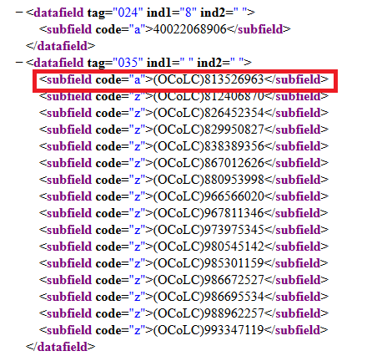

Here we see the availability:

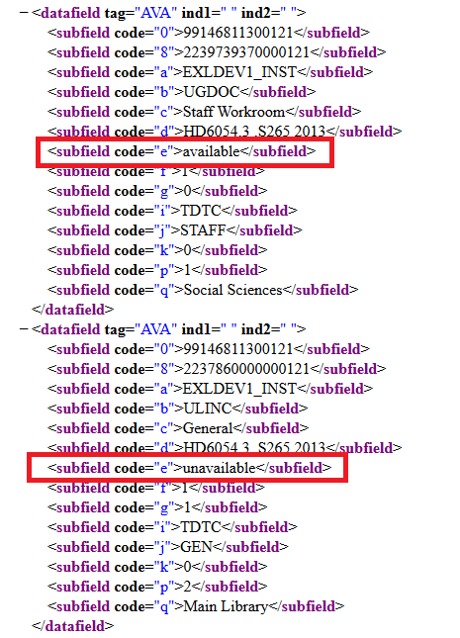

FOUR

This will search for records with 'Lean in" in the title
- http://eu00.alma.exlibrisgroup.com/view/sru/EXLDEV1_INST?version=1.2&operation=searchRetrieve&recordSchema=marcxml&query=alma.title=%22Lean%20in%22

Here we see there are 4 records with "Lean in" in the title:

